**MIDDLE SCHOOL CROSS COUNTRY YEAR-LONG WORKOUT PLAN**

**Table of Contents:**

|  |  |
| --- | --- |
| **Introduction** | **Page 2** |
| **Calendar** | **Page 3** |
| **Warm-ups** | **Page 6** |
| **Workouts** | **Page 10** |
| **Stretch Sets** | **Page 19** |
| **Regression/Progression Options** | **Page 25** |
| **Assessment Testing** | **Page 27** |
| **Nutrition** | **Page 30** |
| **Picture Index**   * **Warm-up** * **Workout** * **Stretch** | **Page 31**  **Page 38**  **Page 46** |

**INTRODUCTION**

This binder contains a breakdown of a year-long workout plan for middle schoolers aged 10-14 participating in Cross Country. The year is broken down into segments of Pre-Season, In-Season, Post-Season, and Off-Season. Each segment will have workouts and stretch plans, as well as designated rest periods. Alternative sports have been accounted for during Off-Season but are not mandatory. There is a photo index at the back of the binder, as well as optional Regressions and Progressions for each exercise provided. The school training schedule is based off of the co-ed Brownsburg East Middle School In-Season practice and meet schedule from 2023-2024, provided by Coaches Cameron Brock and Theresa Chatterton.

**CALENDAR KEY**

**PRE-SEASON**

**IN-SEASON**

**POST-SEASON**



**OFF-SEASON**

**ASSESSMENT DAY**

**FULL REST**

**ACTIVE REST/ALTERNATE SPORT**

**Calendar Schedule:**

**Warm up #1 Workout #1/#2 Stretch Plan #1 :**

**Warm up #2 Workout #3 Stretch Plan #2**

**Warm up #3 Workout #4 Stretch Plan #3**

**Warm up #4 Workout #5 Stretch Plan #4**

**WARMUP#1:**

**\*\*Have measured length of track/area be 20 yards\*\***

* **Mario Jumps** 
  + **Down to cone and back to start**
  + **Repeat 3x**
* **Bear Crawl** 
  + **Down to cone**
  + **Jog backwards to start**
  + **Repeat 3x**
* **High Knees** 
  + **Down to cone**
  + **Jog back to start**
  + **Repeat 3x**
* **Butt Kickers** 
  + **Down to cone**
  + **Jog backwards to start**
  + **Repeat 3x**
* **1 lap around track**
  + **Light jog-medium pace**

**WARMUP #2:**

**\*\*Have measure length of track/area be 20 yards\*\***

* **Alligator Drag**
  + **Down to cone**
  + **Jog back to start**
  + **Repeat 2x**
* **Mountain Climbers in place** 
  + **30 seconds**
* **Leg Scoops** 
  + **Down to cone**
  + **Jog backwards back to start**
  + **Repeat 2x**
* **Bunny Jumps** 
  + **Down to cone**
  + **Jog back to start**
  + **Repeat 2x**
* **Star Shuffles** 
  + **Down to cone and back to start**
  + **Repeat 2x**

**WARMUP #3:**

**\*\*Have measured length of track/area be 20 yards\*\***

* **Inchworms** 
  + **Down to cone**
  + **Jog back to start**
  + **Repeat 2x**
* **Crab walk** 
  + **Down to cone**
  + **Walk back to start**
  + **Repeat 2x**
* **Backwards jog** 
  + **Down to cone**
  + **Forward jog back to start**
  + **Repeat 3x**
* **Single leg hops with high knee** 
  + **Down to cone**
  + **Switch legs, repeat single leg hop to start**
  + **Repeat 2x**
* **Speed Bounds**
  + **Down to cone**
  + **Alternate starting leg, Speed Bound back to start**
  + **Repeat 3x**

**WARMUP #4: **Need exercise ladder for equipment\*\***

* **Elephant Dangle Walk** 
  + **Down to cone**
  + **Jog back to start**
  + **Repeat 2x**
* **Superman into Hollow Body Hold**
  + **15 seconds per side**
  + **Rest 15 seconds after completion of 1 rep**
  + **Repeat for a total of 4 reps**
* **Frog Jumps** 
  + **Down to cone**
  + **Jog backwards to start**
  + **Repeat 2x**
* **Double A-Skip** 
  + **Alternate legs down to cone**
  + **Leg scoop back to start**
  + **Repeat 2x**
* **Ladder Hops Sideways** 
  + **Down to end of ladder**
  + **Walk to start**
  + **Repeat 2x**

**WORKOUTS**

**WORKOUT #1: **Used for Baseline for future workouts\*\***

**\*\*Equipment needed: track, grass field, recording notebook\*\***

* **Cardio Portion:**
  + **Light Jog- 1 minute**
  + **3-2-1 run with 60 seconds in between**
* **Bodyweight Exercises** 
  + **Squat to volitional fatigue (record # of squats for baseline)**
  + **Nordic Curls to volitional fatigue (record # of curls for baseline)**
  + **Pushups to volitional fatigue (record # of pushups for baseline)**
  + **Plank to volitional fatigue (record time for baseline)**
* **Core Exercises**
  + **Dead bug (focus on slow, controlled movements)** 
    - **30 seconds, rest for 1 minute**
    - **Repeat x3**
  + **Cross-body Straddle Toe Touches** 
    - **15 per side, rest 30 seconds**
    - **Repeat x3**
  + **Pidgeon to forward fold, 5 second fluid movement**
    - **5 per side (no rest needed with alternating sides)**
    - **Repeat x3 per side**

**WORKOUT #2:**

**\*\*Equipment needed: Jump rope, cones, recording notebook, dumbbell or kettlebell\*\***

* **Cardio/Plyometrics/Agility:**
  + **ABC Skips**
    - **Area Length: 20 yards**
    - **Down to cone**
    - **Light jog back to start position**
    - **Rest 30, 60, 90 seconds respectively**
    - **Repeat 3x**
  + **Jumping rope**
    - **90-60-30 seconds**
    - **60 second rest in between reps**
* **Body Weight (FULL BODY) Exercises**
  + **Squats**
    - **Take number recorded for baseline and calculate 70% of baseline**
    - **Repeat 3x**
    - **Rest 30-60 seconds between reps**
    - **Once able to complete full 12 reps per set with proper form, weight can be added in 2.5 lb. increments (either dumbbell or kettlebell). (**MAKE SURE TO RECORD NEW NUMBER EACH PRACTICE**).**
  + **Nordic Curls**
    - **Take number recorded for baseline and calculate 70% of baseline**
    - **Repeat 3x**
    - **Rest 60 Seconds between reps**
    - **Once able to complete 6 reps per set with proper form, increase reps in increments of 2 up to 12 total reps per set** **(**MAKE SURE TO RECORD NEW NUMBER EACH PRACTICE**).**
  + **Pushups**
    - **Take number recorded for baseline and calculate 70% of baseline**
    - **Repeat 3x**
    - **Rest 60 seconds in between sets**
    - **Once able to complete 6 reps per set with proper form, increase reps in increments of 2 up to 12 total reps per set (**MAKE SURE TO RECORD NEW NUMBER EACH PRACTICE**).**
  + **Plank Hold**
    - **Take number recorded for baseline and calculate 70% of baseline**
      * **Use this number as beginning “end time” for plank hold**
    - **Once able to hold for above time at least two practices in a row, increase in increments of 15 seconds.**
    - **\*\*MAKE SURE TO RECORD NEW NUMBER EACH PRACTICE**.**

**WORKOUT #3:**

**\*\*Equipment needed: step, TRX or Adjustable Olympic Rings, recording notebook, bands\*\***

* **Cardio:**
  + **1 mile jog at medium pace**
    - **Rest 2-3 minutes**
* **Fully Body Workout:**
  + **Squat Jumps**
    - **Perform exercise to volitional fatigue**
    - **Rest Period: 2 minutes**
    - **Repeat 3x**
    - **Record number of reps performed per set for progress purposes**
  + **Step Ups**
    - **Perform exercise to volitional fatigue**
    - **Rest Period: 3 minutes**
    - **Repeat 2x**
    - **Record number of reps performed per set for progress purposes**
  + **TRX or Rings Assisted Pullups (3 variations)**
    - **Measure equipment to make sure that when sitting on ground with arms overhead, arms are straight, and equipment does not have slack.**
    - **Perform 3-6 reps with Pronated Grip**
    - **Perform 3-6 reps with Supinated Grip**
    - **Perform 3-6 reps with Row Grip**
    - **Rest Period: 3-5 minutes**
    - **Repeat 3x**
  + **Wall Tibialis Anterior Lifts (dorsiflexion)**
    - **Dorsiflexion to volitional fatigue**
    - **Rest Period: 2 minutes**
    - **Repeat 3x**
    - **Record number of reps performed per set for progress purposes**
  + **Banded Kickbacks (Backwards, Adductors, Abductors) **start with lightest band and progress weight after being able to complete 10 reps two sessions in a row\*\***
    - **Wrap band around pole at ankle level and around ankle**
    - **8-10 reps normal Kickbacks**
    - **8-10 reps Adductor Crossbody kicks**
    - **8-10 reps Abductor Side kicks**
    - **Rest Period: 2 minutes**
    - **Repeat 3x**

**WORKOUT #4:**

**\*\*Equipment needed: exercise ladder\*\***

* **Cardio Portion:**
  + **Ladder Drills**
    - **Forward-Facing Single leg A-Skip alternating square**
      * **Down and back alternating legs x3**
      * **60 second rest in between**
    - **Square Toe Touches** 
      * **Down and back x2**
      * **60 second rest in between**
    - **Straddle Squat Hops**
      * **Full ladder length x3**
      * **Rest 30 seconds in between each**
* **Lower Body Exercises:**
  + **Bridge to Knee Curl** 
    - **3 sets, 15 reps each**
    - **60 second rest**
  + **Compass Rose Lunges**
    - **Start Right Leg: forward lunge, side lunge, backward lunge**
    - **Left Leg: backward lunge, side lunge, forward lunge**
    - **4 sets, alternating starting leg**
    - **90 second rest in between rotations**
* **Core Exercises:**
  + **Superman** 
    - **15 second hold**
    - **30 second rest**
  + **Hollow Body Hold**
    - **15 second hold**
    - **30 second rest**
  + **Repeat 3x**

**WORKOUT #5:**

**\*\*Equipment needed: NONE\*\***

* **Cardio:**
  + **1 mile run**
    - **Rest Period: 2-3 minutes**
  + **Burpees (4-Count move)**
    - **3-5 reps (base rep amount based on form)**
    - **Rest Period: 60 seconds**
    - **Repeat 3x**
* **Main Workout:**
  + **Jumping Jacks**
    - **Perform for 30 seconds**
    - **Rest Period: 15-30 seconds**
    - **Repeat 3x**
  + **Donkey Kicks/Fire Hydrants**
    - **8-10 reps per leg donkey kicks**
    - **8-10 reps per leg fire hydrants**
    - **Rest Period: 60 seconds**
    - **Repeat 3x**
  + **Stationary Single Leg Hops**
    - **Perform to volitional fatigue each leg before rest**
    - **Rest Period: 30 seconds**
    - **Repeat 3x**
  + **Plank Party**
    - **Plank hold for 30 seconds**
    - **Rest Period: begin at 60 seconds, decrease by 15 seconds until no rest period**
    - **Repeat Plank hold for 30 seconds until last student with proper form is left**
    - **Last student with proper form wins the competition**

**STRETCH PLANS/COOL DOWNS**

**Stretch Plan #1:**

**\*\*For each stretch, hold for 15-30 seconds unless otherwise directed\*\***

* **Standing forward fold**
* **Standing forward fold with bent knee**
* **Convex/Concave Seated Back Stretch**
* **Crossed Leg Seated Twist**
* **Seated Ankle/Toe Touch**
* **Seated Side Lunge**
* **Cat/Cow alternation**
* **Kneeling Lunge into Half Split**
* **Kneeling Side Lunge**
* **Pigeon Pose into Upward Dog**
* **Butterfly Pose**
* **Goddess Pose**

**Stretch Plan #2:**

**\*\* For each stretch, hold for 15-30 seconds unless otherwise directed\*\***

* **Sun Salutation**
* **Warrior 2 Pose**
* **Chair Pose**
* **Forward Fold**
* **Wide Angle Forward Fold**
* **Garland Pose**
* **Half Lord of the Fishes Pose**
* **Bound Angle Pose**
* **Seated Head to Knee Forward Bend**
* **Happy Baby Pose**
* **Supine Spinal Twist**
* **Corpse Pose**

**Stretch Plan #3:**

**\*\* For each stretch, hold for 15-30 seconds unless otherwise directed\*\***

* **Forward Fold**
* **Downward Dog into Upward Dog**
* **Side Plank**
* **Puppy Pose**
* **Thread the Needle Pose**
* **Bound Angle**
* **Seated Forward Fold**
* **Camel Pose**
* **Bow Pose**
* **Supine Spinal Twist**
* **Bridge Pose into Bilateral Knee to Chest Curl**
* **Child’s Pose**

**Stretch Plan #4:**

**\*\*This Stretch Plan is a PNF (assisted) Stretching Routine. Partners are necessary\*\***

**\*\*For each stretch involving contraction, have student contract or push against assisting partner for a count of 3, and hold the relaxation pose for 6-10 seconds. Repeat each 3x\*\***

* **Hold/Relax Hamstring Stretch**
  + 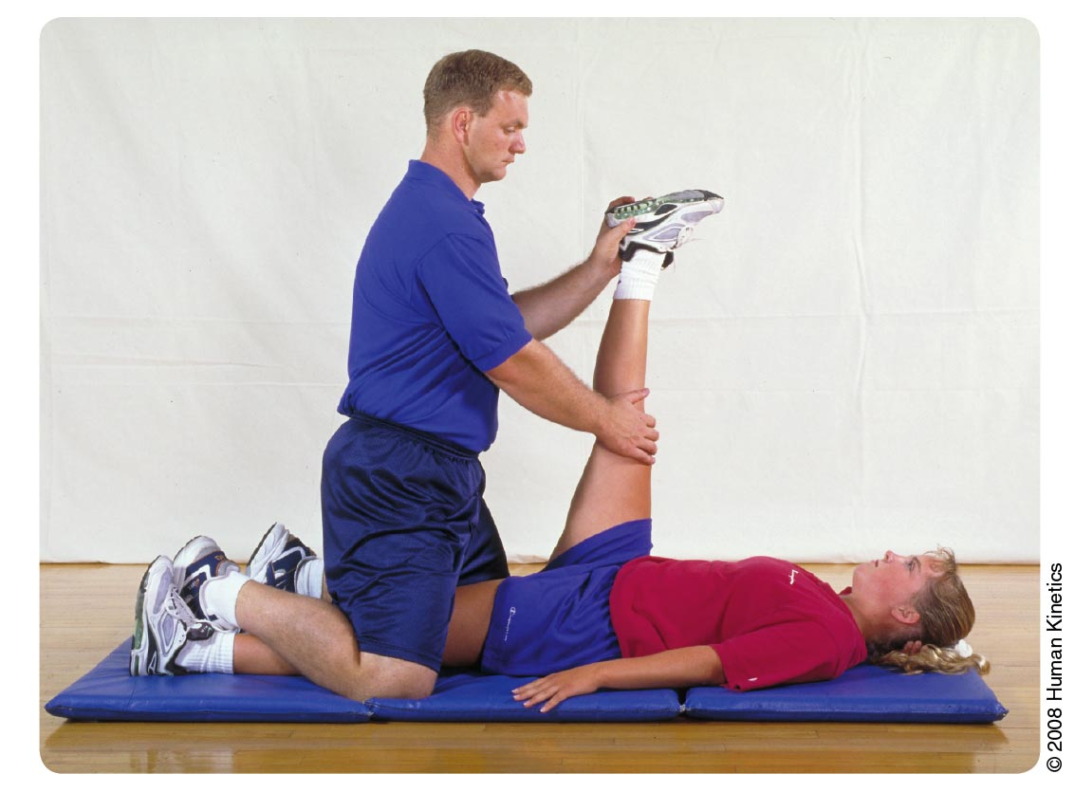
* **Contract/Relax Hamstring Stretch**
  + 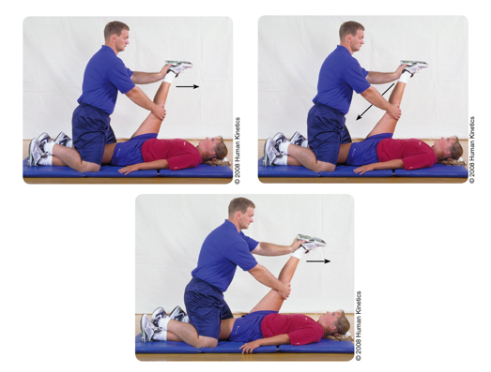
* **Contract/ Relax Quadriceps**
  + 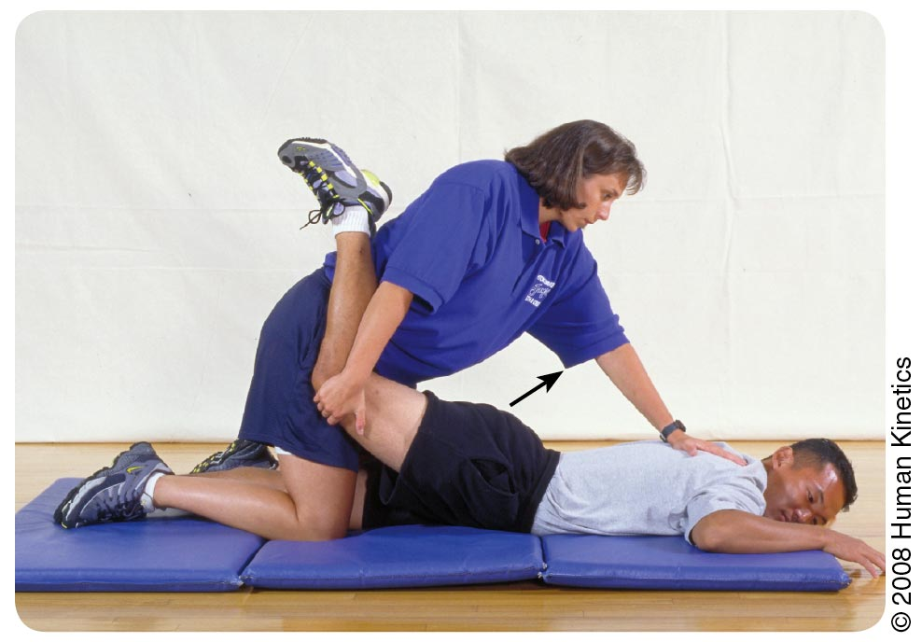
* **Contract/Relax Groin**
  + 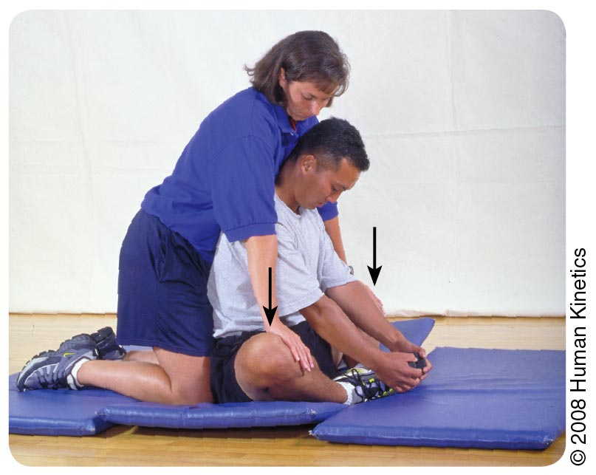
* **Contract/Relax Calf Stretch**
  + 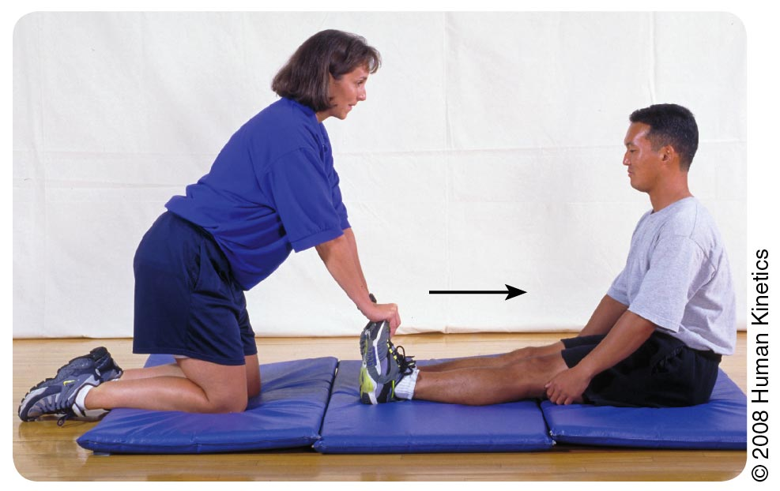

**Regression/Progression Workout Options for Main Workouts:**

* **Squat:** 
  + **Regression: Sit-to-Stands**
  + **Progression: Jump Squat, Bulgarian Split Squat**
* **Nordic Curls:** 
  + **Regression: Prone Leg Curls**
  + **Progression: Machine-Weighted Curls**
* **Pushups:**
  + **Regression: Kneeling Pushup, Standing Wall Pushup**
  + **Progression: Clap Pushups**
* **Plank:**
  + **Regression: Table/Wall Plank**
  + **Progression: High/Low Planks, Up/Down Planks**
* **Assisted Pullups:** 
  + **Regression: Scapular Elevations/Depressions**
  + **Progression: Pullups**
* **Compass Rose Lunges:**
  + **Regression: Stationary/Assisted Held Lunge**
  + **Progression: Walking Lunges**
* **Burpees:**
  + **Regression: Step-back Plank to stand**
  + **Progression: 5-count Burpee**

**ASSESSMENT TESTING:**

**\*\*Testing Days Will Include the Following Assessment Testing Unless Otherwise Directed\*\***

* **3k Run Test:**
  + **\*\*Only done at BEGINNING and END of IN-SEASON block\*\***
  + **Equipment needed: Track/Run path (preferably the path used for In-Season Meets), stopwatch, recording notebook**
  + **Record time for each student**

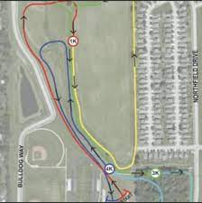

* **Start/Stop Sprint test**
  + **Equipment needed: Track, cones, recording notebook**
  + **Place cones approximately 15 yards apart for 60 yards**
  + **Record times between 1st and 2nd cone and 3rd and 4th cone**
  + **Have student sprint from cone 1 to cone 2, walk from cone 2 to cone 3, and sprint from cone 3 to cone 4**
* **Squat/Plank/Pushup/Box Jump**
  + **Use as baseline for establishing form**

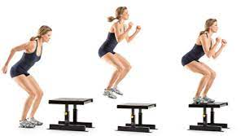

* **Flexibility Test:**
  + **Equipment needed: Mat, partner, goniometer, recording notebook**
  + **Using PNF stretching (contract/relax), assess flexibility of hips (adductors, abductors), hamstring, quads, calves, and ankles.**



* **Vertical Jump Test:**
  + **Equipment needed: recording notebook, Vertec**
  + **Record 3 jumps for each student**

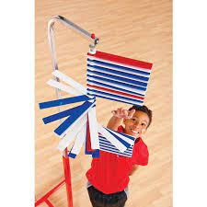

**NUTRITION**

**\*\*The following is NOT a nutrition plan. These are all healthy alternatives for snacks and meals throughout the year to make sure that the student is meeting their macronutrients\*\***

* **SNACK OPTIONS:**
  + **Greek yogurt with granola and fruit**
  + **Cut Vegetables (carrots, peppers, cucumbers, celery, etc.)**
  + **Fruit (apples, bananas, etc.) with Peanut Butter**
  + **Nuts with Raisins/Craisins and Cheese Cubes**
  + **Hard-Boiled Eggs**
  + **Oatmeal with Fruit**
  + **10-12 oz Protein Shake with Fruit or Peanut Butter**
* **BREAKFAST OPTIONS:**
  + **Eggs (scrambled, Sunnyside up, sandwich, etc.)**
  + **Oatmeal with Fruit**
  + **Breakfast Burritos**
  + **Greek Yogurt with Fruit and Granola**
  + 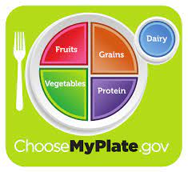**Fruit Salad with Nuts**
* **LUNCH/DINNER OPTIONS:**
  + **Use MyPlate for portion sizing**

**PICTURE INDEX (ALPHABETICAL ORDER):**

**WARMUPS:**

* **Alligator Drag**

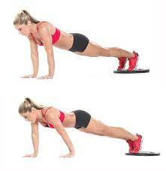

* **Bear Crawl**

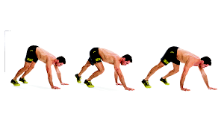

* **Bunny Jumps**

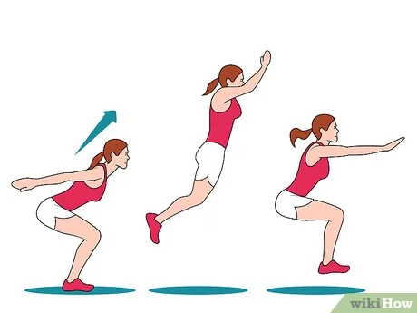

* **Butt Kickers**

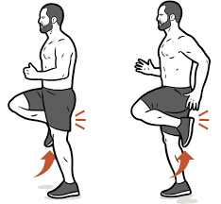

* **Crab walk**

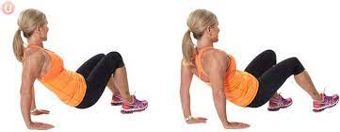

* **Elephant Dangle Walk**

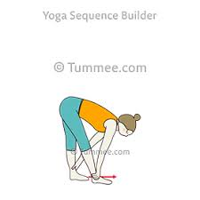

* **Frog Jump**

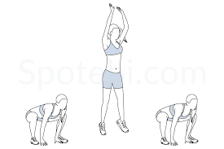

* **High Knees**

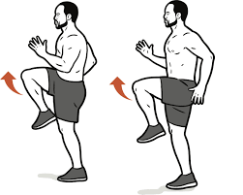

* **Hollow Body Hold**

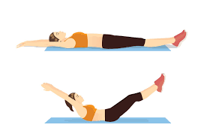

* **Inchworms**

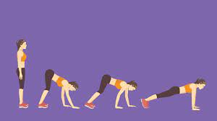

* **Ladder Hops Sideways**

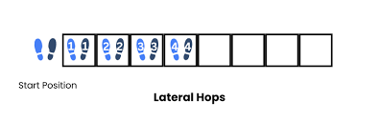

* **Leg Scoops**

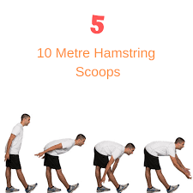

* **Mario Jumps**

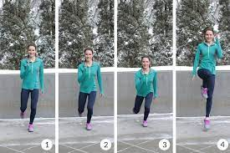

* **Mountain Climbers**

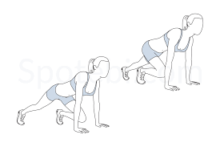

* **Single Leg Hops with High Knee**

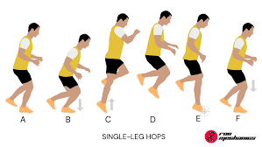

* **Speed Bounds**

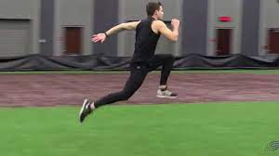

* **Star Shuffles**

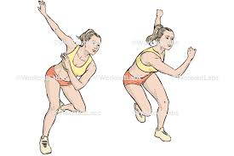

* **Superman**

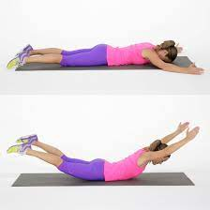

**WORKOUTS:**

**ABC Skips**

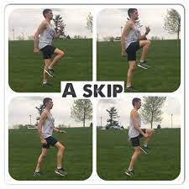

**B SKIP**

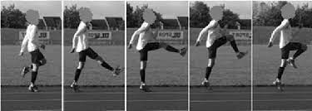

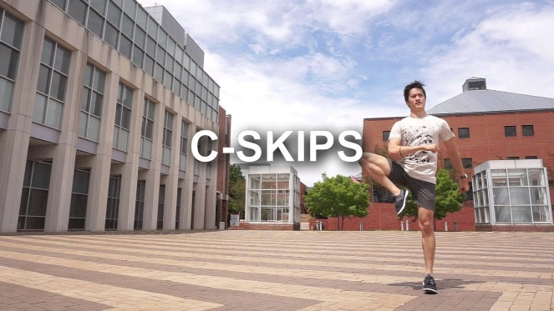

**Banded Kickbacks**

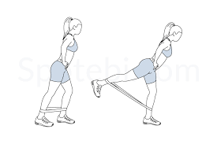

**Bridge to Knee Curl**

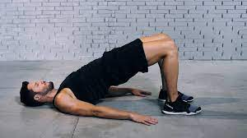

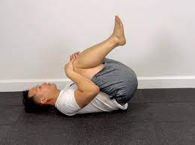

**Burpee (5-Count)**

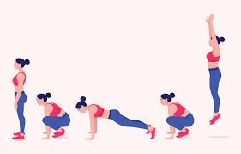

**Cross-body Straddle Toe Touch**

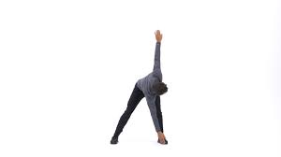

**Dead bug**

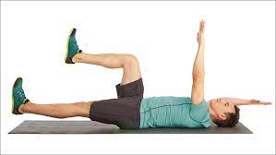

**Donkey Kick**

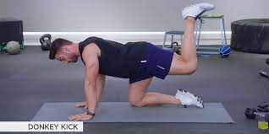

**Fire Hydrant**

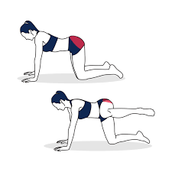

**Jumping Jack**

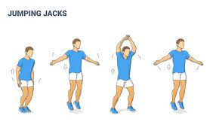

**Lunges (Forward, Side, Backwards)**

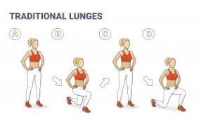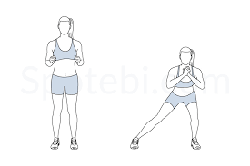

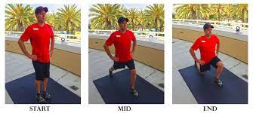

**Nordic Curl**

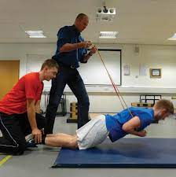

**Pigeon**

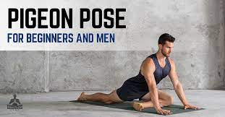

**Plank**

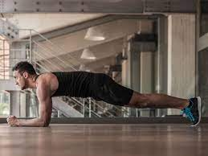

**Pushup**

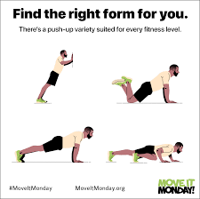

**Ring/ TRX Assisted Seated Pull up**

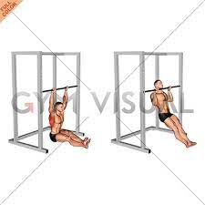

**Squat**

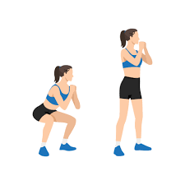

**Squat Jump**

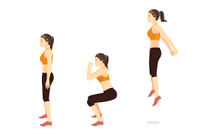

**Step Up**

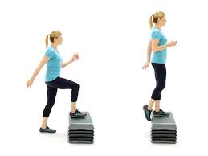

**Wall Tibialis Anterior Lifts**

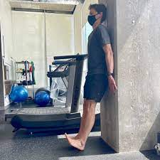

**STRETCHES:**

**Bound Angle/Butterfly Pose**

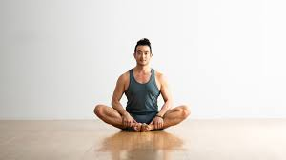

**Bow Pose**

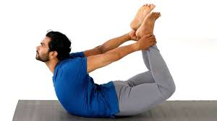

**Camel Pose**

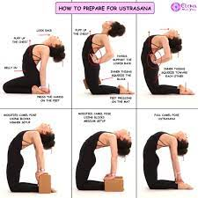

**Cat/Cow alternation**

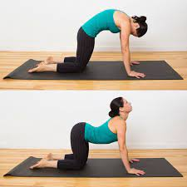

**Chair Pose**

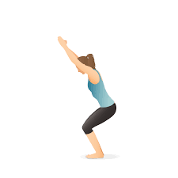

**Child’s Pose**

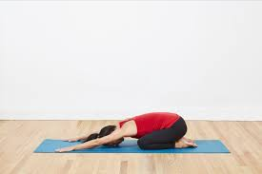

**Convex/Concave Seated Back Stretch**

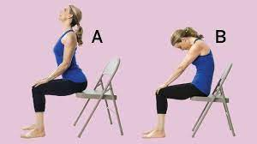

**Corpse Pose**

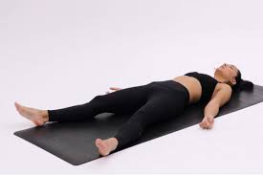

**Crossed Leg Seated Twist**

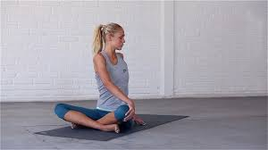

**Downward Dog into Upward Dog**

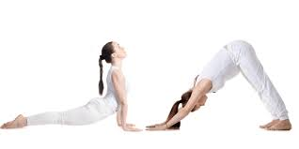

**Forward Fold**

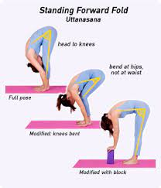

**Garland Pose**

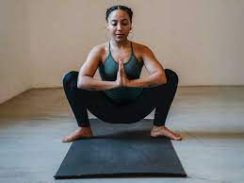

**Goddess Pose**

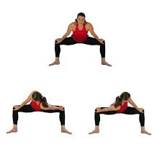

**Half Lord of the Fishes Pose**

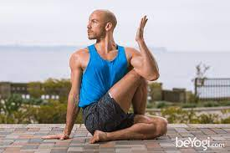

**Happy Baby Pose**

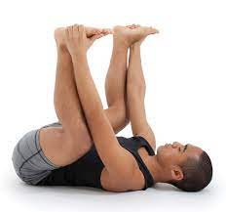

**Kneeling Lunge into Half Split**

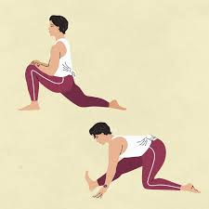

**Kneeling Side Lunge**

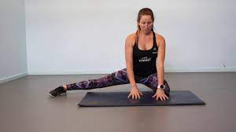

**Pigeon Pose into Upward Dog**

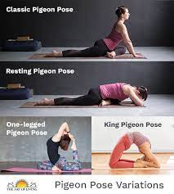

**Puppy Pose**

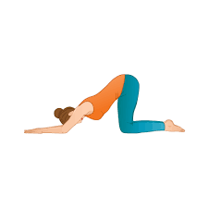

**Seated Ankle/Toe Touch**

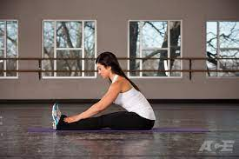

**Seated Head to Knee Forward Bend**

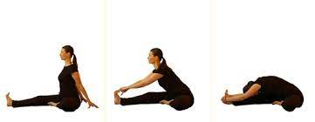

**Seated Side Lunge**

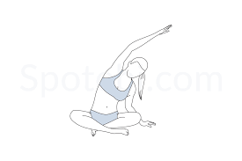

**Side Plank**

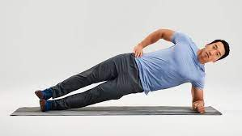

**Sun Salutation**

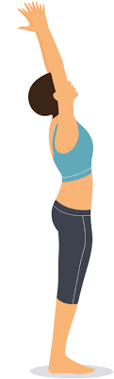

**Supine Spinal Twist**

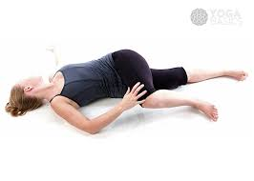

**Thread the Needle Pose**

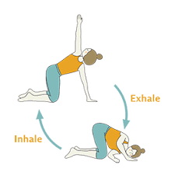

**Warrior 2 Pose**

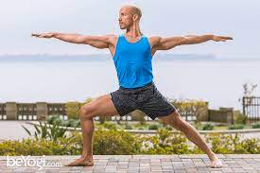

**Wide Angle Forward Fold**

